Algebra 3-4 Name: ____________________

Chapter 4 Re-Test Block: ________

For problems 1 – 3, simplify the expression.

1. 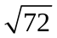 2. 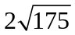

3. 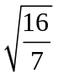

For problems 4 – 6, factor the expressions completely.

4. x² + 9x + 14 5. 64y² – 9

6. 3x² + 12x – 15

For problems 7 – 8, solve for x by factoring.

7. 2x² – x – 21 = 0 8. 2x² + 7x + 3 = 0

For problem 9, solve for x by finding the square root.

9. (x + 2)² + 3 = 17

For problem 10, solve for x by completing the square.

10. x² – 4x + 9 = 0

For problems 11 – 13, write the expression as a complex number in standard form.

11. 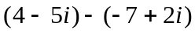 12. 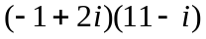

13. 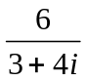

For problem 14, solve for x by using the Quadratic Formula.

14. x² – 3x + 5 = 0

For problems 15 – 19, solve the quadratic equations by using the best method.

15. 4x² + 2x – 5 = 0 16. x² = -16

17. x² + 4x = -2x + 3 18. 8r² + 7 = 5r² + 4

19. 2x² + x – 6 = 0

For problem 20, answer the question.

20. How do we find the discriminate? What does the discriminate tell us?

